Software Developer Checklist

Details | Answers
Primary contact name: | Antony Cartwright
Primary contact job title: | Director
Primary contact email address: | admin@diyaccounting.co.uk
Company Name: | DIY Accounting Limited
Company Registration Number: | 06846849
Business Address: | 37 Sutherland Avenue, Leeds, LS8 1BY
Business Telephone Number: | 07801 559561
Website address: | https://submit.diyaccounting.co.uk
LinkedIn address (if any): | n/a
Twitter address (if any): | n/a
Product Name: | DIY Accounting Submit
Sandbox Application Name: | DIY Accounting Submit
Sandbox Application ID: | ee551bc4-9a71-4042-9179-53b2bdd6e2fb
Production Application Name: | DIY Accounting Submit

Is your product for in house use by your own company only, or is it for retail/commercial use and you plan to sell/licence the product? (Please delete options below as appropriate).
Retail or commercial

Is your product a full digital record keeping solution, file-only (bridging product), or both?
(Please delete options below as appropriate).
File-only (Bridging software)

Which VAT schemes does your product support? (Please delete Yes/No as appropriate).
Cash Accounting | Yes
Annual Accounting | Yes
Flat Rate | Yes
Retail | Yes
Margin | Yes
Exemption | No

Which endpoints have been developed for? (Please delete Yes/No as appropriate).
Retrieve VAT obligations | Yes
Submit VAT return for period | Yes
View VAT Return | Yes
Retrieve VAT liabilities | No
Retrieve VAT payments | No
Retrieve VAT penalties | No
Retrieve financial details | No
Retrieve Customer Information | No

Are you targeting a particular customer demographic or business sector?
UK VAT-registered sole traders and small businesses who need a simple, accessible way to submit VAT returns to HMRC. Focus on businesses using spreadsheets or basic accounting who need MTD-compliant bridging software.

Question (Please delete Yes/No as appropriate). | Answer
Does your software meet the definition of “Digital” as described in VAT Notice 700/22?  Note: See VAT Notice 700/22 Section 4.2.1. | Yes
Is there any manual keying permitted in boxes 1-9 of the VAT return?  Note: Manual element must be removed before a Production application can be approved – See VAT Notice 700/22 Section 3.2.1. The boxes must be populated from the customer’s digital record and no manual keying is permitted in the 9 boxes of the VAT return itself. | Yes
Can your product import from a spreadsheet or CSV file? | No
Can your product import from multiple sources to amalgamate data? | No
Can box 5 contain a negative amount?  Note: Box 5 cannot contain a negative amount, the minimum value is 0.00 – see VAT documentation for “Submit VAT return for Period”. Our systems will identify if the figure is a positive or negative dependent upon which figure (in Box 3 or Box 4) was higher. | No
Do boxes 6 – 9 contain pence?  Note: These fields should contain whole pounds only. If pence is included, this should be to 2 zeroed decimal places | No
Is the Period Key visible?  Note: Period Keys should not be shown to the customer, these are for software use to ensure the return is recorded against the correct obligation | No
Is the Legal Declaration shown on screen prior to submission of the return?  Note: It must be shown – Please add prior to data submission if it is missing. A copy of the declaration text can be found in the VAT (MTD) end-to-end service guide. Please include a screenshot of the text displayed in your software at the point of submission in the cell below so that we can check that the correct text has been used in the software. | Yes
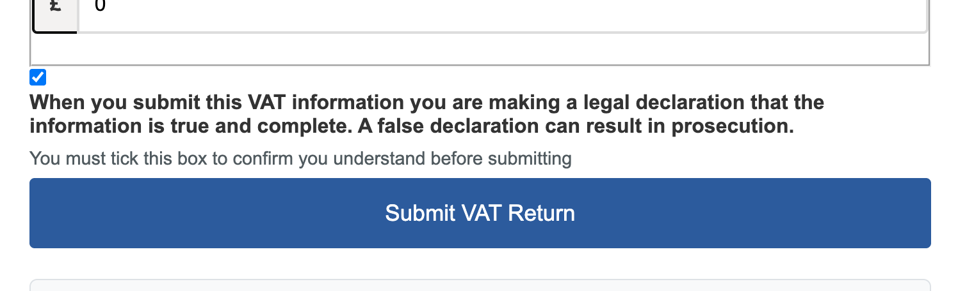
Have you conducted testing in the last 2 weeks?  Note: If not could you please do so as our testing logs are only retained for a 14 day period. | Yes
Have you conducted any error testing?  Note: Although not mandatory it is beneficial | Yes
Is your product built to UK standards and conventions (e.g. UK dates, £ not $ etc.)? | Yes
Is your product a white label? (In general, white label branding is a practice in which a product or service is produced by one company and then rebranded by another company to make it appear to be their own) | No
Is your product GDPR compliant?  Note: See Terms of Use – “Storing Data” | No
Does your product meet the Web Content Accessibility Guidelines (minimum level AA)?  Note: See Terms of Use – “Accessibility” | Yes

Sign-off
Completed by: | Antony Cartwright, Director
Date: | 25 January 2026
Any comments: | We have documentation of our methods and test evidence available.  FPH validation Error: MISSING_HEADER - gov-client-public-port  DIY Accounting Limited response: Our application uses AWS CloudFront CDN. The client's source port is not preserved through the CloudFront edge network, making this header impossible to collect reliably.  FPH validation Warning: MISSING_HEADER - gov-vendor-license-ids  DIY Accounting Limited response: This is open-source software and we do not issue license keys to users.

